2025/6-Reading Texts -Literacy Yearly Overview -Year A
Literary Leaves are book-based comprehension planning resources for Y2-Y6 designed to support teachers with the teaching of reading, using whole books, rather than extracts. They can be used in whole-class or guided reading sessions.
Each Literary Leaf has 10-20 session notes, with each session focusing on skills from the Programme of Study, so that children have the opportunity to secure them deeply. In many cases the same question stem is repeated to ensure teachers can model how to answer questions, before the children apply it themselves.
Literary leaves are not intended to replace teachers' own planning but to support them to ask the right questions at the right time, and plan for activities that help children to become critical readers.
 | Term 1 Who am I? | Term 2 Who am I in place and time? | Term 3 How does the world work? | Term 4 How do we organise ourselves? | Term 5 How do we express ourselves? | Term 6 How do we make the world a better place?
Preschool
Reception/Year 1
Year 1/2 | 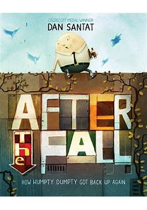After the Fall -15 sessions  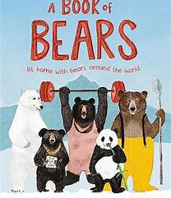A book of Bears -12 sessions | 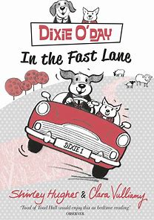Dixie O’Day In the Fast Lane -12 sessions  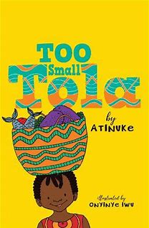Too small Tola -12 sessions | 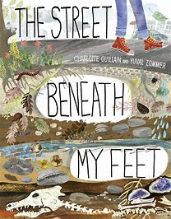The street beneath my feet -15 sessions  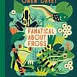 Fanatical about Frogs -12 sessions | 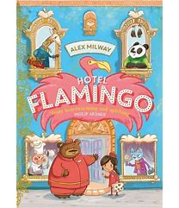Hotel Flamingo-15 sessions  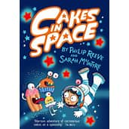Cakes in Space -15 sessions | 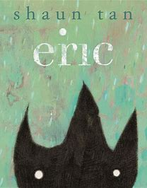Eric -12 sessions  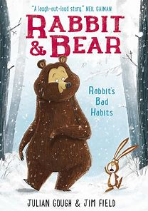Rabbit and Bear -15 sessions | 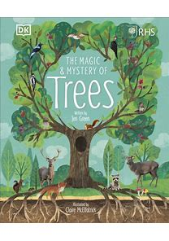The magic and Mystery of trees -15 sessions  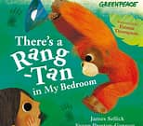There’s a Rang-Tan in my bedroom-10 sessions
Year 3/4 | 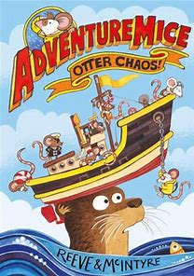Adventure Mice Otter Chaos -15 sessions  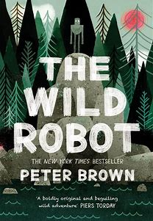 The Wild Robot -15 sessions | 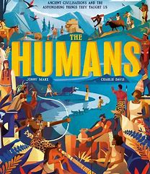 The Humans -15 sessions  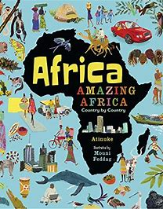 Africa, Amazing Africa - 15 sessions | 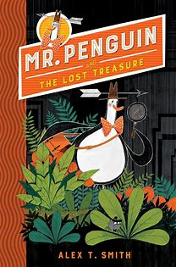Mr Penguin and the lost treasure -15 sessions  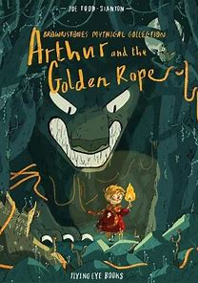Arthur and the Golden Rope -12 sessions | 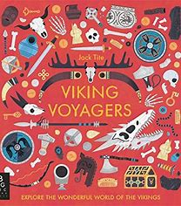-Viking Voyager -15 sessions  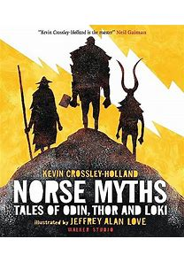Norse Myths -20 sessions | 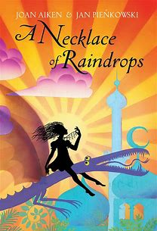A Necklace of Raindrops -15 sessions  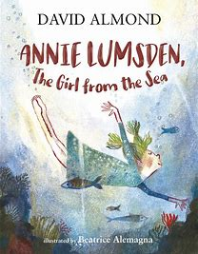 Annie Lumsden, the girl from the sea -15 sessions | 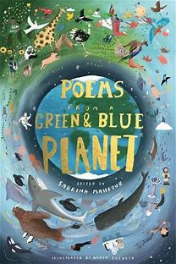Poems from a green and blue planet-15 sessions  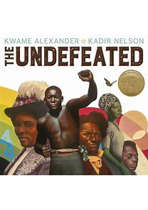The Undefeated -15 sessions
Year 5/6 | 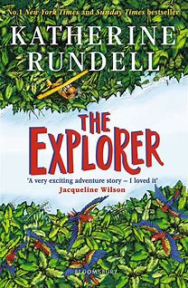The Explorer -20 sessions | 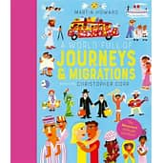Journeys and Migrations -15 sessions  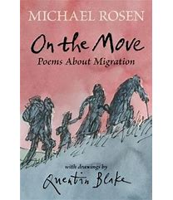Michael Rosen, On the Move -Poems about migration -15 sessions | 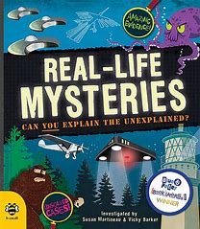Real-Life Mysteries -15 sessions | 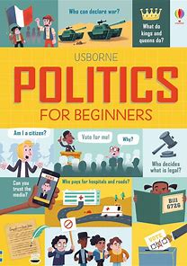Politics for beginners -15 sessions  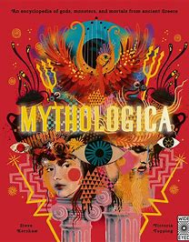 Mythologica -15 sessions ?!?  IF NOT USE THE HUMANS | 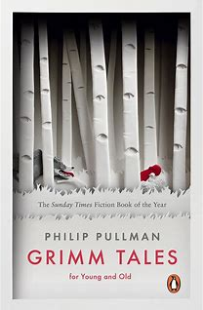Grimm Tales -15 sessions | 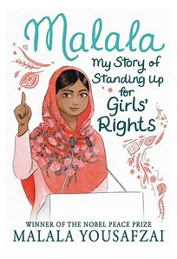Malala, My story of standing up for Girls’ rights -15 sessions
TOPICS | Y1/2 Geography-Local study, family. | Y1/2 History-Transport and Aviation  Y3/4 History-Romans  Geography-Migration  Y5/6-Geography -How does where a country is (and its history) influence its culture, economy, and role in the world?  History-Shang Dynasty | Y1/2 History-Kings and Queens  Geography-DIfferent environments, materials and weather.  Y3/4 History-Victorian inventions  Y5/6 Geography-Mapwork | Y3/4 History-Anglo Saxons/Vikings  Geography-Kings/Invaders rise of democracy  Y5/6-Ancient Greeks? |  | Y1/2 History-Environmental changes in living memory  Geography-Environmental  Y3/4 Geography-Town planners  Y5/6 Geography-Climate change  History-Art and and the Mayan civilisation

