2025/6-Literacy Yearly Overview -Year A
 | Term 1 Who am I? | Term 2 Who am I in place and time? | Term 3 How does the world work? | Term 4 How do we organise ourselves? | Term 5 How do we express ourselves? | Term 6 How do we make the world a better place?
Preschool
Reception/Year 1 | 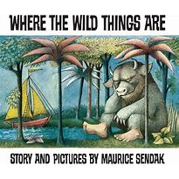R Where the Wild Things Are Max becomes a ‘Wild Thing’ and goes on an adventure. Outcome: Own version narrative.  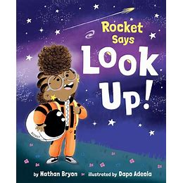  R Look Up! Rocket loves space and meteor showers but her brother prefers gaming. Outcome: narrative own version | 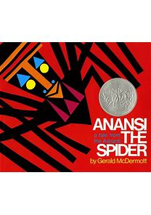R Anansi the spider Ghanaian traditional folk tale. Outcome: Booklet about spiders  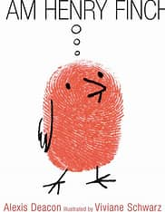 R I am Henry Finch A little bird who gets it all wrong. Themes of problem solving and thinking. Outcome: Guidebook how to think | 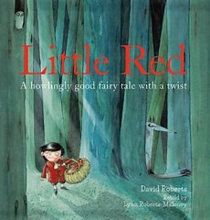R Little Red A retelling of classic tale. Outcome: Alternative character version  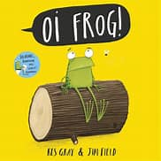R Oi Frog! Rhyming animal tale. Outcome: own version rhyming narrative | 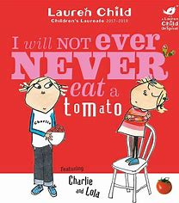R I will not ever never eat a tomato A Charlie and Lola story about fussy eating! Outcome: Own story about fussy eating  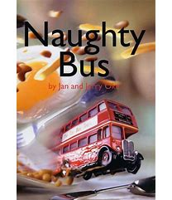Y1 Naughty Bus  A tale of journeys and explorations. Outcome: Own adventure story | 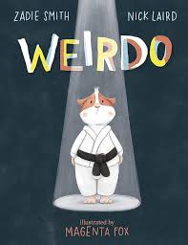  R Weirdo Story of the power of being different. Outcome: Instructional leaflet on being yourself.  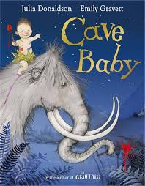  Y1 Cave Baby Baby takes a ride on a wooly Mammoth! Outcome: narrative retelling. | 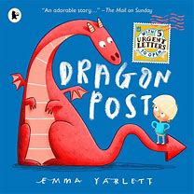Y1 Dragon Post A story of friendship and asking for help. Outcome: Guide how to look after your dragon.  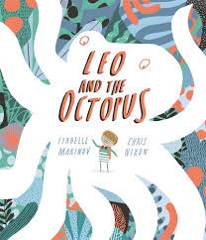  Y1 Leo and the Octopus Leo feels different to everyone else until he meets another octopus. Main Outcome; Fact File.
Year 1/2 | 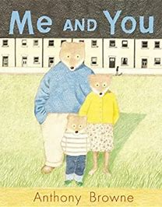Y2 Me and You -Goldilocks and a modern retelling. Outcome: Sequel story  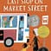Y2 Last stop on market street Follow the bus route home with a boy. Links to community. Outcome: Narrative | 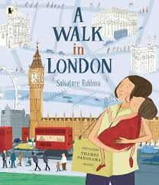  Y2 A Walk in London: tour guide, instructions, persuasive posters, setting descriptions, captions, diary entries. Main Outcome: Guide  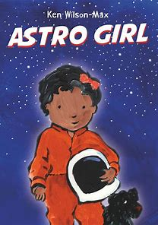 Y1 Astro Girl Dreaming big and being ambitious. Outcome: Fact File | 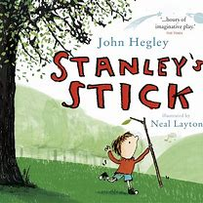Y1 Stanley’s Stick -With Stick in hand Stanley goes on many adventures. Theme of nature. Outcome: Narrative  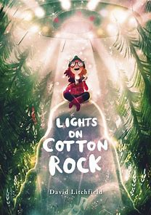Y1/2 Lights on Cotton Rock When a spaceship lands on cotton rock all her dreams have come true! Outcome: narrative | 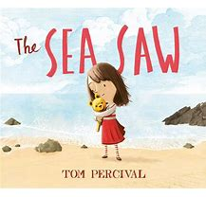Y1 The Sea Saw -Tale of a lost toy after a day at the beach. PSHE themes of change. Outcome: Narrative  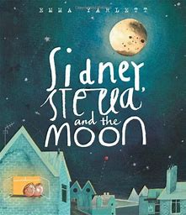 Y1 Sidney, Stella and the Moon. -Twins who don’t like to share work together to find a new moon. Outcome: Fact File | 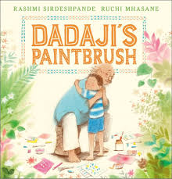  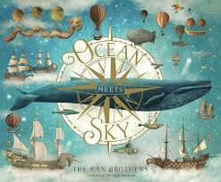  Y2 Ocean Meets the Sky: FInn sets out to find where ocean meets sky and hopefully where his grandpa is. Outcome: extended narrative  Y1 Dadaji’s Paintbrush: Bereavement and art. Main outcome: Own version narrative | 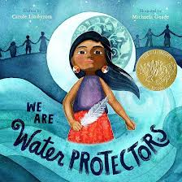Y2 We Are Water Protectors: Environmentalism. Main outcome: Environmental campaign.  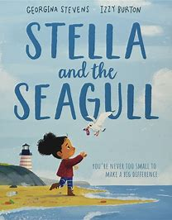Y1 Stella and the Seagull Seagull gets poorly from plastic. Environmental activism. Outcome: Narrative about environment.
Year 3/4 | 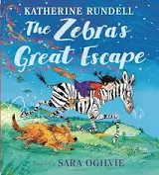Y3 The Zebra’s Great Escape- Something has escaped and they have to discover who or what it is. Picture book about bravery, friendship and taking action. Outcome-Escape narrative  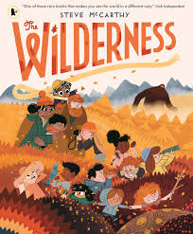Y3 The Wilderness-In a family of adventurers Oktober prefers the warmth of indoors. Story of true bravery. Outcome-Guide to the wilderness | 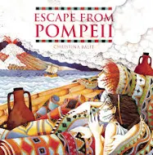 Y3 Escape from Pompeii -Historical fiction based around ancient rome with an outcome of a newspaper report.  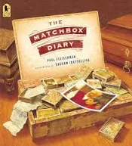Y4 The Matchbox Diary -Girl finds grandfather's treasures and he tells her stories from his past. Outcome -Non-Chronological report | 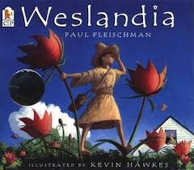Y4 Weslandia -A story about civilisations and growing crops. Outcome-Non chronological report.  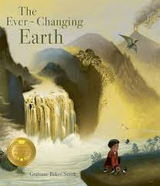 Y4 The ever-changing Earth -journey through the earth’s evolution. Outcome: narrative sequel. | 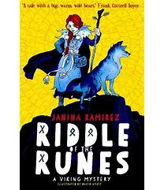Y4 -Riddle of the Runes -Set in the viking age follows the adventurous Alva as she is thrown into solving a puzzle with extremely high stakes.  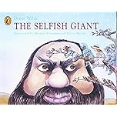  Y4 The Selfish Giant – the giant builds a wall to keep people out but they do find their way back in. Outcome-Own version narrative about kindness. | 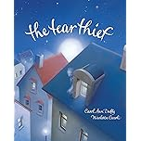  Y3 The Tear Thief – a moving story about how we express our feelings. Main outcome- Newspaper Article.  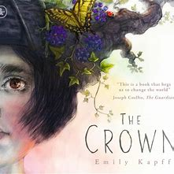 Y4 The Crown -Speaking from the future, a girl wears a crown made from the rubbish passed down to her by previous generations.  Main Outcome -Information Text | 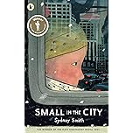  Y3 Small in the City – movement through the city, identifying key parts and finding a way back home. Outcome-Narrative from alternative perspective  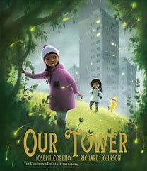 Y3-Our Tower - Story of going on a fantasy adventure from a tower block to a tree. Outcome-Fantasy Narrative
Year 5/6 | 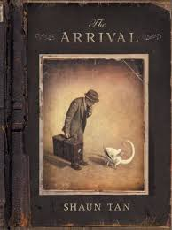Y6 The Arrival -A story of migration and life as a refugee. Outcome: Own narrative  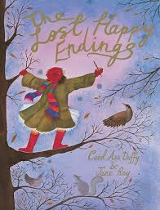Y5 Lost Happy Endings -What would happen if we lost the happy ending to stories? Outcome-Prequel | 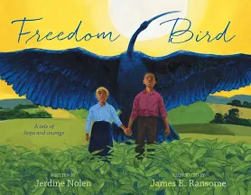Y5 Freedom Bird -Enslaved brother and sister who dream their way to freedom. Outcome-Biography  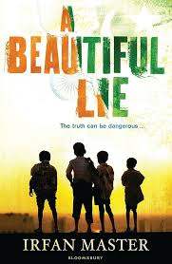  Y6 A Beautiful Lie – set in India and based on a story of tolerance and family during the partition in 1947. Outcome: New Chapters. | 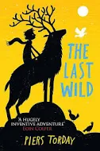Y6 The Last Wild. -Science Fiction story about an extraordinary boy. Outcome: Dystopian narrative.  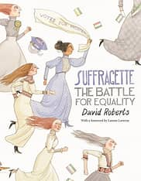Y6 Suffragette -History of the battle for equal rights for women. Activism and protest themes.  Outcome: Persuasive campaign | 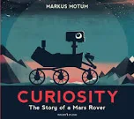Y5 Curiosity: The story of a Mars Rover -The story of significant moments in Space exploration. Outcome: Explanation text.  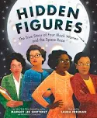  Y5 Hidden Figures – the story of the women behind NASA. Outcome: Non Chronological report. | 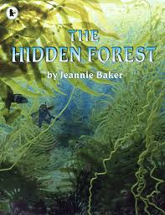Y6 The Hidden Forest -Based on the artwork of collage, giant kelp forests. Outcome: Balanced Argument.  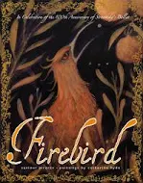  Y5 Firebird – folk tale about a firebird stealing a king’s apples. Outcome: Fairytale Narrative. | 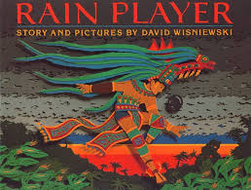Y6 Rain Player A story about Mayan beliefs and culture. Outcome: Analytical Essay.  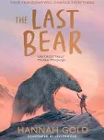  Y6 The Last Bear A moving story of the last polar bear on Bear Island. Outcome: Newspaper report
Topics: | Y1/2 Geography-Local study, family. | Y1/2 History-Transport and Aviation  Y3/4 History-Romans  Geography-Migration  Y5/6-Geography -How does where a country is (and its history) influence its culture, economy, and role in the world?  History-Shang Dynasty | Y1/2 History-Kings and Queens  Geography-DIfferent environments, materials and weather.  Y3/4 History-Victorian inventions  Y5/6 Geography-Mapwork | Y3/4 History-Anglo Saxons/Vikings  Geography-Kings/Invaders rise of democracy  Y5/6-Ancient Greeks? |  | Y1/2 History-Environmental changes in living memory  Geography-Environmental  Y3/4 Geography-Town planners  Y5/6 Geography-Climate change  History-Art and and the Mayan civilisation

