Summer 1 - Fatima Class Homework
Supporting your child with homework helps boost their confidence, strengthens learning, and builds good study habits. Just a few minutes working together can make a big difference to their progress and enjoyment of learning. If you’d like tips on how to help at home, please don’t hesitate to ask—we’re happy to support you.
Weekly tasks:
- Learn spellings for a test on a Tuesday
- Numbots/TTRS challenges
- Reading as often as possible
- Year 1 will have a phonics task and year 2 will have a SATs question
R.E Project for the term - to be handed in the week beginning 18th May
May is the Month of Mary - Create a Mary Artwork
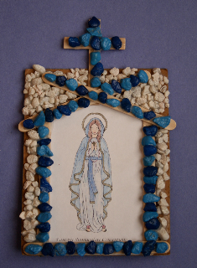

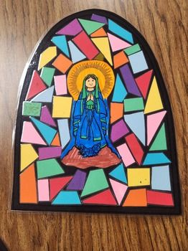
Create a piece of artwork showing Mary. Include a short line of scripture that you think is important to Mary’s life or to our lives today. Be ready to explain why you chose it.
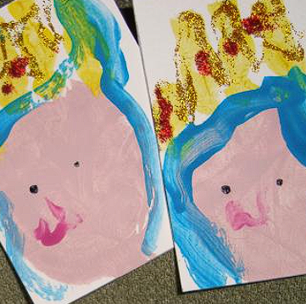
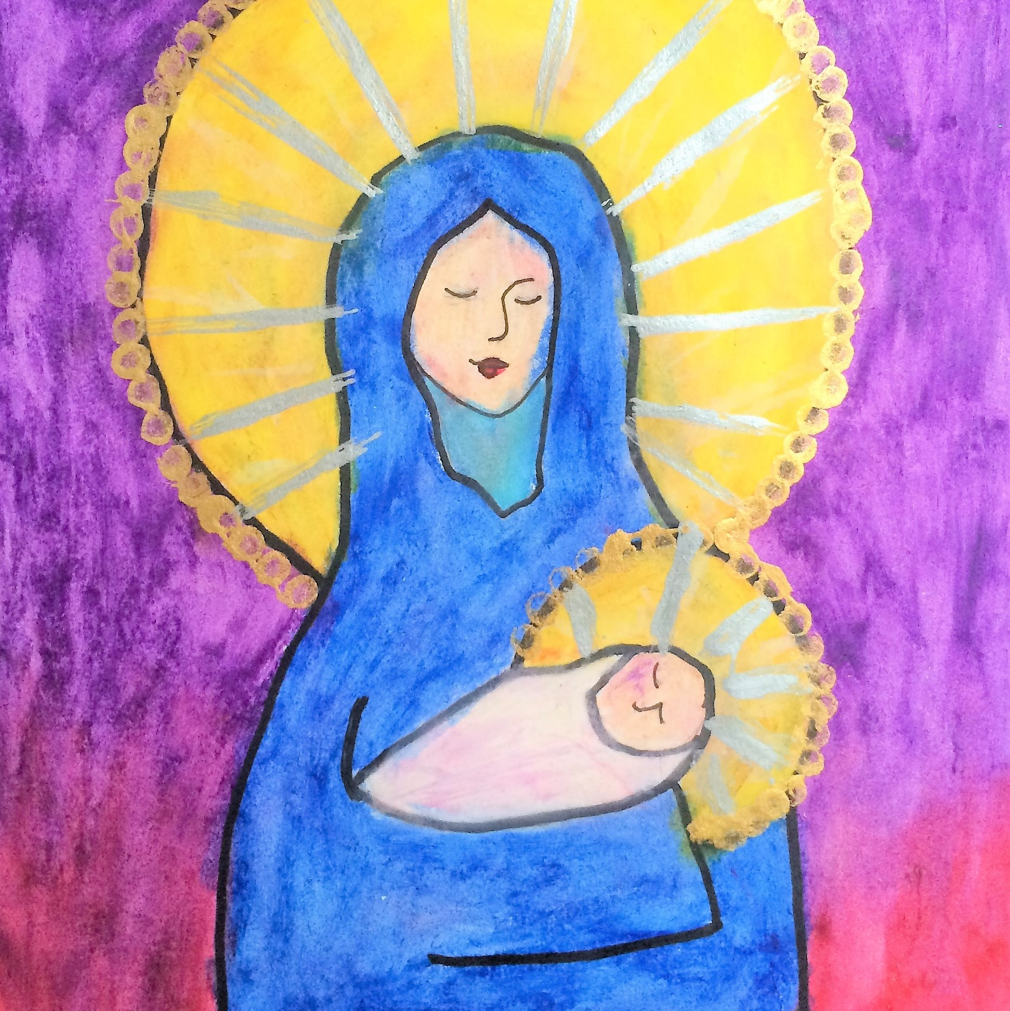

Year 2
Test Date (Tuesday) | Spelling Pattern | Words to practise
21st April | Step 25:  Words where the digraph ‘ey’ makes an /ee/ sound | key, donkey, monkey,  chimney, valley, trolley,  journey, turkey, jockey, kidney
28th April | Step 26:  Words where ‘a’ makes an /o/ sound | want, watch, wander,  wand, quality, quad,  wasps, squat, quantity, squash
5th May | Step 27:  Words where ‘or’ and  ‘ar’ make an /er/ or /or/ sound | word, work, worm, world,  worth, warm, war,  towards, warn, warned
12th May | Step 28:  Words where ‘si’ and ‘s’ makes an /zh/ sound | television, treasure, usual,  measure, pleasure,  decision, vision, leisure, version, visual
19th May | Step 29:  Words ending in  ‘-ment’ and ‘-ness’ | payment, enjoyment,  agreement, achievement,  adjustment, darkness, rudeness, sadness, greatness, kindness
2nd June  After half term | Step 30:  Words ending in ‘-ful’ and  ‘-less’ | careful, playful, thankful,  helpful, wonderful, useless,  careless, homeless, hopeless, spotless

Year 1
Test Date (Tuesday) | Spelling Pattern | Words to practise
21st April | Step 25:  Words where the digraph  ‘ou’ makes an  /ow/ sound | out, mouth, sound, proud,  shout, about, around,  found, mound, count
28th April | Step 26:  Words where the digraph ‘ow’ makes an /ow/ or /oa/ sound | down, town, frown, how,  brown, own, grow, show,  blow, snow
5th May | Step 27:  Words ending in ‘y’  /ee/ and ‘ve’ /v/ | very, happy, funny, party,  family, give, have, love,  shove, dove
12th May | Step 28:  Words with the digraphs ‘ue’ and ‘ew’ | Tuesday, blue, clue, true,  rescue, threw, few, drew,  grew, new
19th May | Step 29:  Words where the digraph  ‘ie’ makes an /igh/ sound | lie, tie, pie, cried, tried,  died, spied, fried, dried, tied
2nd June  After half term | Step 30  Words where ‘ie’ makes  an /ee/ sound | chief, thief, piece, brief,  handkerchief, field, belief,  priest, shield, grief

