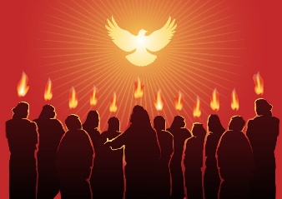
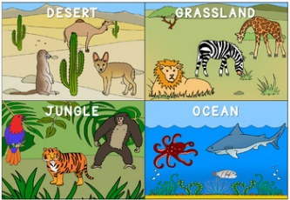
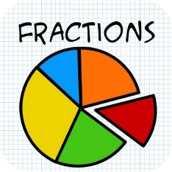
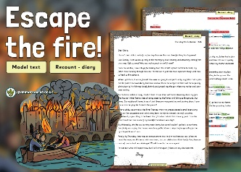
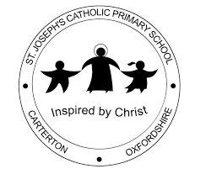
As readers and writers, we are exploring diary recounts through a Great Fire of London text. We will be deconstruction the texts to understand the features of a dairy before writing our own.
Our key texts are: Escape the Fire!
Our phonic sounds in Year 1 are alternative sounds and tricky words are: Unsafe, return,
quickly, fearful, terrifying, survive, action, direction, question, parents, again, behind, last after
Fatima Curriculum Map
Summer 1 2026

As scientists, we will explore and compare the differences between living things, dead things, and those that have never been alive. We will learn that most living things are suited to specific habitats and understand how different habitats meet the basic needs of plants and animals, and how they depend on one another. We will identify and name a variety of plants and animals in different habitats, including microhabitats, and describe how animals obtain food from plants and other animals using simple food chains. We will also identify and name different sources of food.
Key Vocabulary: Habitat, microhabitat, conditions, adapted, omnivore, herbivore, carnivore, ocean,
woodland, forest, jungle, savanna, desert, mountain
As Theologians we are studying Easter and Pentecost. We will learn stories about the Resurrection and the Risen Jesus, the other characters involved and their reactions. Be able to identify the symbols used during the Easter Season and explain their significance. We will learn the story of Pentecost and understand that the Holy Spirit was the promised gift of Jesus. We will recognise that Confirmation is a celebration of the gift of the Holy Spirit and the role of the Holy Spirit in the lives of Christians today.
Key Vocabulary: Easter - resurrection, Mary Magdalene, Peter, Paschal Candle, Alpha, Omega,
Easter Vigil, Holy Water, Emmaus, Thomas, Doubt. Pentecost - Apostles, Holy Spirit, Holy Trinity,
Confirmation, Sacrament, Oil of Baptism, Oil of Chrism.
As Mathematicians we have 2 topics – money and fractions. We will be working through the steps to be able to count money, recognise notes and coins, calculate Monday and give change, round to a pound, compare money. In the fraction’s unit, we will learn to recognise and find halves, quarters, thirds, three quarters and wholes. We will learn about unit and non-unit fractions and learn to count in fractions to a whole.
Key Vocabulary: part, whole, half, quarter, third, equal, unequal, denominator, digit, numerator,
equivalent, unit fractions, non-unit fractions, split

Our Gospel Values are: Grateful and Generous
Across the Curriculum

As Historians we will learn what London was like in 1666 and compare it to today. We will find out what happened when the Great Fire of London started on 2nd September 1666, why it spread so quickly, and how people tried to stop it. We will learn about important people from the time and explore how we know about the past by looking at evidence like diaries and objects.

As Geographers
(Taught in another term)

As Artists we are using clay to make sculptures. Use a variety of modelling and printing techniques to create sculptures. We will explore colour mixing to create seasonal colours to paint our final pieces.

As Athletes we are developing our PE skills through athletics and a range of field sports including cricket and rounders.

As Musicians
(Taught in another term)

As Design Technologists we are
(Taught in another term)

As Computer Programmers we are exploring what the term data means and how data can be collected. We will explore how attributes can be used to organise data and how data can be presented in the form of pictograms and block diagrams. We will use the data presented to answer questions.

As Deep Thinkers we are learning that God made us to be in loving relationships through parables including The Good Samaritan.

