Class:  Fatima  Year group: 1/2 | Term: 2  Class book:  Astro Girl  A Walk in London | Main context and interesting hook: Who am I in place and time?  Children will explore transport and travel, taking a closer look at RAF Brize Norton and significant individuals who have had an impact on flight such as the Wright Brothers. Through science, children will explore the seasons and weather patterns in the UK as well as climates around the world.
Subject | National Curriculum |  | Sticky Knowledge | Skills | Evidence
English | Literacy:  Word reading and comprehension, writing transcription and composition, vocabulary, grammar and punctuation covered throughout literacy tests.  Guided reading:  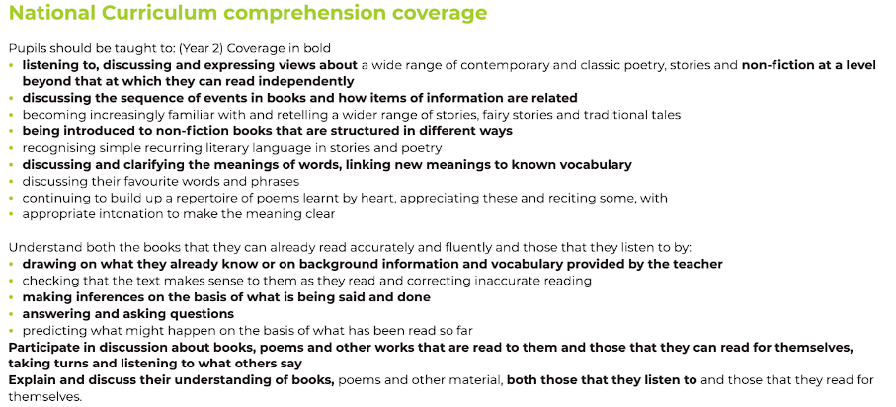  Phonics:  Year 1 – respond speedily with the correct sound to graphemes (letters or groups of letters) for all 40+ phonemes, including, where applicable, alternative sounds for graphemes. Read accurately by blending sounds in unfamiliar words containing GPCs that have been taught  Year 2 - read accurately by blending the sounds in words that contain the graphemes taught so far, especially recognising alternative sounds for graphemes |  | Literacy texts:  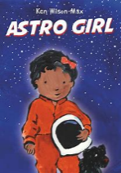  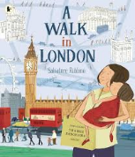  A Walk in London: tour guide, instructions, persuasive posters, setting descriptions, captions, diary entries. Main Outcome: Guide  Astro Girl Dreaming big and being ambitious. Outcome: Fact File  Guided reading texts:      A book of bears continued  Dixie O’Day In the Fast Lane -12 sessions  Phonics: Year 1 – phase 5 graphemes. Year 2 – phase 6 alternative graphemes | Vocabulary, Grammar & Punctuation: Use capital letters, full stops, question marks and exclamation marks correctly in sentences. Understand that words join together to make sentences. Join ideas using and (Y1) and later and, but, or, when, if, that, because (Y2). Sequence sentences to tell a short story or describe an event. Recognise and use different types of sentences: statements, questions, exclamations, and commands. Begin to spot and fix missing punctuation in their writing.  Writing (Composition): Say what they want to write before they write it. Compose sentences orally before writing them down. Sequence sentences logically to make a simple story or explanation. Re-read writing to check it makes sense. Write for different purposes (stories, letters, reports, etc.). Plan what to write by talking or jotting ideas. Proof-read to correct spelling, grammar and punctuation mistakes. Make simple improvements to their writing (add a word, change a sentence, fix punctuation).  Writing Transcription (Spelling & Handwriting) - Spell words using known phonics (GPCs) and common exception words. Write sentences from memory that include familiar spellings and punctuation. Learn different spellings for the same sound (e.g. ai/ay/a-e). Recognise and spell homophones (e.g. there/their/they’re) and near-homophones. Apply spelling rules they have been taught. Form letters correctly and develop neat, consistent handwriting | - Daily phonics taught in phases  - Daily literacy lessons  - Handwriting x4 sessions per week  - Guided reading sessions x4 per week  - Spelling tests on Tuesday  - Literacy books  - Published write books  - Handwriting books  - Spelling books  - Guided reading books  - Phonics assessments  - Reading records  - Interventions  - 1-1 reading year 2 x1 per week, year 1 x2 per week.  - Planning (slides)
Maths | Addition and subtraction: Year 1: Understand and use addition, subtraction, and equals signs; know number bonds and related subtraction facts up to 20; add and subtract numbers up to 20 (including zero); and solve simple one-step addition and subtraction problems using objects, pictures, or missing numbers.  Addition and subtraction year 2: Pupils learn to solve addition and subtraction problems using objects, pictures, and mental or written methods. They should recall facts to 20 fluently and use related facts up to 100. Pupils add and subtract two-digit numbers and ones, tens, or other two-digit numbers, and add three one-digit numbers. They understand that addition is commutative but subtraction is not, and use the inverse relationship between addition and subtraction to check answers and solve missing number problems.  Shape: Recognise, describe, and compare 2-D and 3-D shapes by their properties—such as sides, edges, vertices, faces, and symmetry—and identify 2-D shapes on the surfaces of 3-D shapes. |  | - Step 1 – Parts and wholes  - Step 2 – Systematic number bonds within 10  - Step 3 – Number bonds to 10  - Step 4 – Number bonds to 20  - Step 5 – Addition – add together  - Step 6 – Addition – add more  - Step 7 – Doubles  - Step 8 – Near doubles  - Step 9 – Add three 1-digit numbers  - Step 10 – Find a part  - Step 11 – Fact families – the eight facts  - Step 12 – Take away (how many left?)  - Step 13 – Find the difference  - Step 14 – Missing number problems  - Step 15 – Related facts  - Step 16 – Add and subtract 1s  - Step 17 – Add to the next 10  - Step 18 – Add to a 10  - Step 19 – Add across a 10  - Step 20 – Subtract to a 10  - Step 21 – Subtract from a 10  - Step 22 – Subtract across a 10  - Step 23 – Add 10s  - Step 24 – Subtract 10s  - Step 25 – Add two 2-digit numbers (not across a 10)  - Step 26 – Add two 2-digit numbers (across a 10)  - Step 27 – Subtract two 2-digit numbers (not across a 10)  - Step 28 – Subtract two 2-digit numbers (across a 10)  - Step 29 – Mixed addition and subtraction  - Step 30 – Compare number sentences  - Step 31 – Missing number problems | Understanding number relationships: Recognise parts and wholes, and understand how numbers can be split and combined. Recall and use number bonds within 10 and 20 fluently. Identify related facts for addition and subtraction.  Addition skills Add one-digit and two-digit numbers up to 20 (Year 1) and within 100 (Year 2). Use concrete objects, pictorial representations, and mental strategies to add. Apply strategies such as doubles, near doubles, adding 1s or 10s, adding across and to the next 10. Add two two-digit numbers using place value knowledge and mental or written methods.  Subtraction skills Understand subtraction as ‘take away’ and ‘find the difference’. Use related subtraction facts and inverse relationships. Subtract 1s or 10s, and subtract across tens using place value understanding. Subtract two-digit numbers mentally or using representations.  Fact fluency and problem-solving Recall and use addition and subtraction facts to 20 fluently, and related facts up to 100. Solve one-step and two-step problems using concrete and pictorial methods. Understand and use fact families and missing number problems. Recognise that addition is commutative, but subtraction is not.  Reasoning and comparison Compare number sentences using greater than, less than, and equals symbols. Check answers using the inverse relationship between addition and subtraction. Apply reasoning to explain how they know an answer is correct. | - Daily maths lessons  - Mastering Number fluency sessions x 4 per week  - Maths working wall  - Maths books  - Planning (slides)
RE | Learning as growing as the people of God Year 2 curriculum:  Sharing in the life of Jesus: Mary, The Disciples, Saints and us - This unit is designed to extend the children’s knowledge and understanding of the life of Mary and Jesus and the call of the disciples. They will also learn about some saints who have responded to the call of Jesus. They will also be introduced to the prayer of silence as an opportunity to spend time with God.  Advent - This unit is designed to develop children’s knowledge of the time, symbols and characters of the liturgical Season of Advent. It will focus on Advent being a season of preparation for Christmas through the story of John the Baptist and parish activities. |  | Sharing in the life of Jesus: Mary, The Disciples, Saints and us - Most children will know important stories from the New Testament about the life of Jesus and Mary and the call of the disciples; Know that the Rosary is a special form of Christian prayer. Know about the example of saints and important events in their lives. Understand and take part in a moment of stillness and prayer.  Advent - Most children will that Advent is a season of preparation for Christmas; describe the Advent Wreath and explain why it is a symbol of preparation for Christmas. Know the story of John the Baptist about preparing the way for Jesus. Describe some ways the parish prepares for Christmas. | KU 1 Recognise religious stories  KU 2 Retell, in any form, a narrative that corresponds to the scripture source used  KU 7 Recognise key figures in the history of the People of God  KU 8 Describe the life and work of some key figures in the history of the People of God  KU 13 Use religious words and phrases  ER 1 Say what they wonder about  ER 4 Ask and respond to questions about their own and others’ feelings, experiences and things that matter to them | - RE lessons x2 and a half per week  - RE displays  - Floor book  - Discussions in the classroom  - planning
History | Travel and transport linked to flight and the RAF base  Significant individuals and events |  | Develop a secure chronological framework for recent history.  Understand how and why transport, particularly aviation, has changed over time.  Explore the significance of individuals like the Wright Brothers and Amelia Earhart.  Connect with their local history through RAF Brize Norton.  Use historical enquiry skills to interpret evidence, understand change, and make comparisons between the past and present | Chronology: Order events and people (e.g. Wright Brothers, Amelia Earhart) and use time language such as past and present.  Knowledge: Understand how and why transport, especially flight, has changed over time and its impact locally (RAF Brize Norton).  Enquiry: Ask and answer questions using sources like photos, artefacts, and stories to learn about the past.  Comparison: Identify similarities and differences between past and present transport.  Communication: Use historical vocabulary and simple timelines to explain what they’ve learned. | - History lesson x1 per week  - History books  - Working wall  - planning
PE | REAL PE dance unit - perform dances using simple movement patterns.  Sports with coach - |  | In this unit, the children will learn and develop shapes and circles and create sequences of movement with these through partnering and artistry. | Artistry, partnering, circles, shapes | - PE with Coach on Mondays  - Real PE on Thursdays
DT | Travel and transport:  Design: Create purposeful, appealing products; share ideas through talk, drawings, and models. Make: Use suitable tools and materials for cutting, shaping, joining, and finishing. Evaluate: Explore existing products; assess own work against design criteria |  | Investigate a variety of different vehicles before undertaking the fun task of designing, making and evaluating their own vehicle. They will learn all about wheels, axles and chassis and how they are combined to make the framework of the vehicle, as well as how to create an eye-catching body. | Use the design, make and evaluate approach to create a vehicle. Technical Knowledge: Build strong, stable structures; use simple mechanisms (levers, sliders, wheels, axles). | - Art and DT books  - DT/cross curricular history lessons  - planning
Science | Seasonal changes  observe changes across the four seasons  observe and describe weather associated with the seasons and how day length varies |  | Learn that the UK has four seasons with different weather patterns. Understand how day length changes through the year. Observe how plants, animals, and people are affected by seasonal changes. Collect and record weather and daylight data (rainfall, temperature, sunrise/sunset). Compare weather and natural changes across months and seasons using local examples (e.g., Carterton/Oxfordshire). | - Observing closely natural changes over time.  - Asking simple questions about what they notice.  - Gathering and recording data using simple equipment (rain gauges, thermometers, charts).  - Identifying and classifying changes in plants, animals, and weather.  - Using observations to describe patterns (e.g., longer days in summer).  - Communicating findings through drawings, tables, charts, and discussion. | - Science display  - Science x1 per week  - Science books  - planning
RSE | Ten Ten curriculum:  Unit 2 – me, my body, my health:  Unit 3 – emotional well-being |  | Me, My Body, My Health encourages children to celebrate similarities and differences between people, including our God-given bodies and the things they enable us to do! Teaching also includes maintaining personal hygiene and the physical differences between boys and girls.  Unit 3 – Emotional Well-Being, children will meet presenters Zoe and Joey and fictional character Super Susie. They will help children to understand and articulate their own changing feelings and how other people’s feelings might differ from theirs. Children will learn how they can manage their feelings and about the consequences of their actions. | Me, My Body, My Health – Children recognise and celebrate similarities and differences, understand basic body parts and physical differences between boys and girls, and learn how to keep clean and healthy through good hygiene and self-care.  Emotional Well-Being – Children identify and talk about feelings, understand that others may feel differently, learn ways to manage emotions, and recognise how their actions affect themselves and others. | - Planning  - Weekly lesson  - Mostly discussion and group work but some evidence of baselines kept in RE folder

