
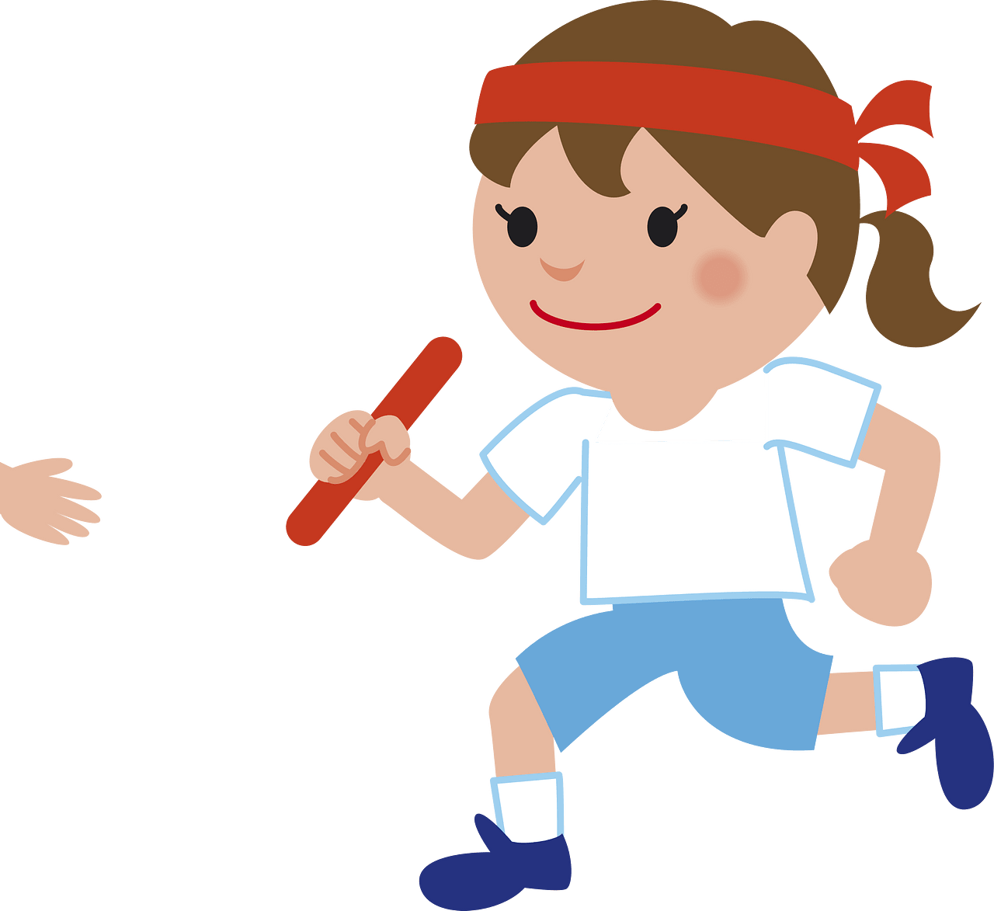

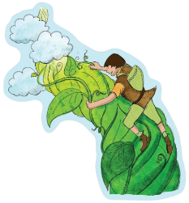

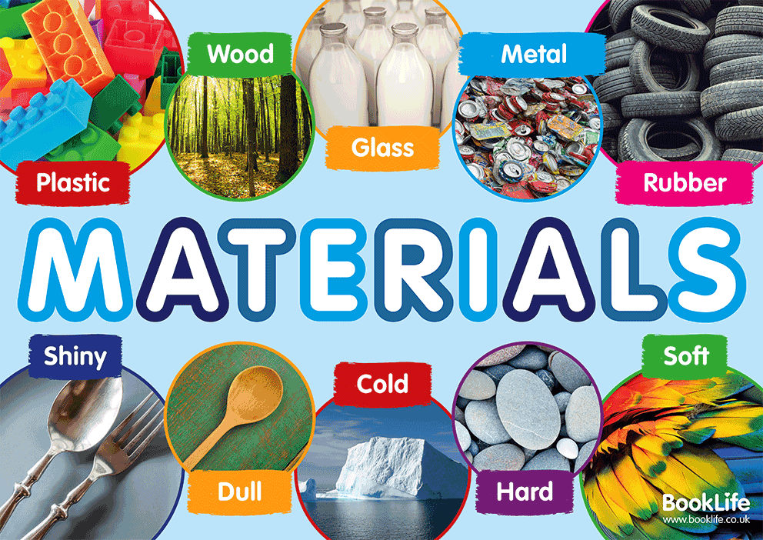
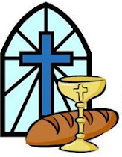
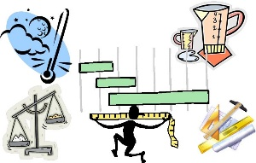
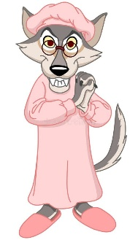
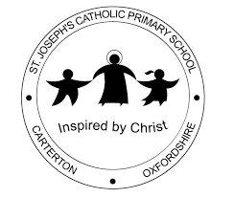
Across the Curriculum
As Geographers Children will use atlases, globes and maps to locate key world and UK features, develop fieldwork and mapping skills, and compare the human and physical geography of Tromsø, Norway, with their local area.

As Athletes we are preparing for sports day by developing our athletic skills. We will be completing different races, practising jumps and throwing. KS1 girls also look forward to the annual girls football event at CCC.

As Musicians Children will learn and perform It’s Ok (Please Just Say), using their voices and sign language to communicate meaning. They will explore expressing emotions through music, singing independently and working collaboratively with others.

As Design Technologists we will explore where fruits and vegetables come from, learn about healthy eating and food hygiene, and develop basic food preparation skills. They will design, make and evaluate a healthy snack inspired by Jack and the Beanstalk.

As Deep Thinkers we will learn about the local and global communities they belong to and explore the rights and responsibilities that come with being part of them.

History, computing and art are taught in alternating terms.
As Mathematicians Children will extend their understanding of multiplication and division, including doubling, halving, quotative and partitive division. They will also develop their knowledge of statistics and measurement through practical problem-solving and real-life contexts.
Key Vocabulary: multiply, divide, groups, array, repeated addition, double, halve, sharing, partitive division, quotative division, data, tally, chart, pictogram, block graph, compare, interpret, measure, length, height, mass, capacity, estimate, centimetre, metre, gram, kilogram, millilitre, litre

As scientists, Children will explore everyday materials, identifying their properties and investigating why certain materials are suitable for different objects. They will also investigate how materials can be changed by squashing, bending, twisting and stretching.
Key Vocabulary: flexible, fragile, human, material, natural, object, observation, property, protect, record,
results, rigid, suitable, unsuitable, design, opaque, transparent, waterproof

As Theologians Year 2 will explore what it means to belong to God’s family, learn about the role of the parish and people with special responsibilities, and discover how the Church began through the Apostles. As well as develop their understanding of the Mass, exploring how Christ is present when we gather, in the Word, and in the Eucharist. Year One will share in the life of Jesus, focusing on Jesus calling the disciples and what it means to be a follower of Christ. Children will explore what it means to follow Jesus today and how belonging to the Church helps Christians live out their faith in different ways.
As readers and writers, we are focusing on traditional tales. We will be writing a recount letter as Little Red. We will also be writing a setting description of the candy house as well as writing some personal recounts and instructions. We will also be having a big focus on handwriting this term
Our key texts are: Little Red, Candy House
In Phonics, Year Ones will be learning alternative graphemes while Year 2 focus on spelling rules

Fatima Curriculum Map
Summer 2 2026

Our Gospel Values are: Attentive and discerning

