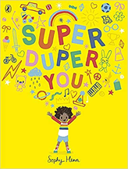
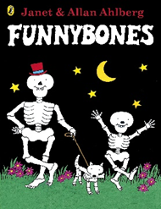
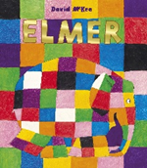
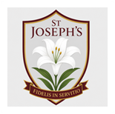
As readers and writers, we are exploring new stories to provide us with the emotional literacy we need to be able to talk about our feelings with our new class! We will be using books to share & celebrate how differences make us special!
Our key texts are: Colour Monster Goes To School, Elmer, Ruby’s Worry, Funnybones, Super Duper Me, The Gruffalo, Peace at Last

Across the Curriculum

As Geographers we are exploring where we live and how we travel to school! We will be building our homes in the construction area, and mark-making our journeys to school!

As Artists we are experimenting with a range of tools & materials to create portraits & self-portraits! We will be looking closely in mirrors to notice different features about ourselves, and comparing ourselves with our friends to reinforce that although we are all different, everyone is an important member of Mustard Seeds.

As Athletes we will be introduced to simple healthy choices, such as eating a variety of foods, moving our bodies, etc, and will be challenged with practical movement investigations, such as bending, stretching, jumping, twisting, and wiggling!

As Musicians we will be introduced to ‘Rhyme Time’ where we will be learning new nursery rhymes every fortnight to lay the best possible foundations for phonics in reception.
As Deep Thinkers we are being introduced to the story of Creation, where God created the Earth, sea, stars, plants, animals & humans. We will be engaging with the story creatively through sound, movement & discussion.
As Scientists we are beginning to name different parts of the body, and understand why we need them. We will use body outlines & songs to name familiar body parts, and mirrors to identify eyes, ears, nose, and mouth. We will also be beginning to understand that there are important parts inside our bodies, and exploring how we can keep our bodies healthy!
Key Vocabulary: skeleton, bones, strong, healthy, body, head, arms, hands, fingers, legs, feet, eyes, ears, nose, mouth, see, hear, move
As Mathematicians we are making comparisons between objects relating to size, and talking bout & exploring 2D & 3D shapes. We will be experimenting with size change, such as what happens when we stretch dough, squeeze a sponge, jump in a puddle, etc! We will also be encouraged to play freely with blocks, puzzles, and shapes.
Key Vocabulary: sides, corners, straight, flat, round, large, small
.

As Theologians we are exploring the Creation story, and learning that God made us & loves us! We will be exploring parts of creation that can be found within Forest School, and embedding the Sign of the Cross as we learn that prayer is a peaceful moment of connection with God.

Key Vocabulary: creation, love, world, good, amen, cross, prayer, Father, Son, Holy Spirit, thanksgiving, care, dignity, precious
Our Gospel Values are: Compassionate and Loving

