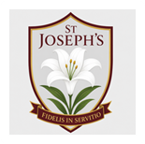


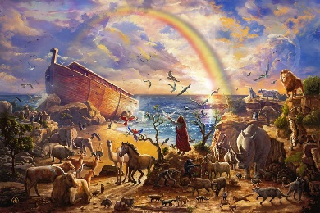
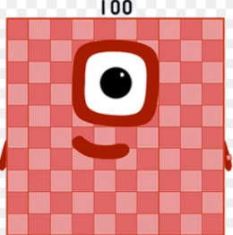
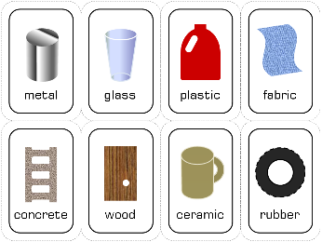
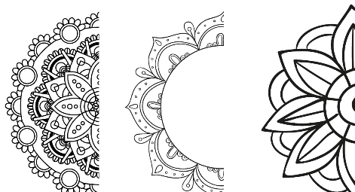
Vines Curriculum Map
Technology
Autumn 1 2026

Our Gospel Values are: Compassionate and Loving
As Theologians we are learning about creation. We will begin by learning there are two parts of the bible. Specifically focusing on stories from the Old Testament, including Noah’s Ark. Children will be leaning about stewardship and how we can care for God’s creations. To link with this and putting our faith into action, Vine class will be arranging the Harvest Festival. Collecting food donations and emailing supermarkets for support to give to those who need it, thanking God for his gifts by helping others.
Key Vocabulary: Old Testament, Baptism, responsibility, promise, convent
As Scientists we are we exploring materials, the properties and objects they are used for. Children will investigate materials and properties in the classroom and put this into action with experiments. Children will examine how sustainability of everyday materials and how solid objects shapes can be changed. They will use simple tests and data to answer questions.
Key Vocabulary: Stretching, bending, twisting, stretching, properties, materials.
As Mathematicians we are focusing on place value to 100, securing year 1/2 learning before moving on to calculation with 20 as well as ensuring we can fluently add and subtract within 10. To support this we will also be doing ‘maths meetings’ (which children may refer to as Numberblocks lessons) which is an additional 10 minutes of maths fluency lessons after lunch 4 times per week, these are themed on the Numberblocks TV show so children love these short sessions.
Key Vocabulary: Part, whole, addend, sum, minued, subtrahend, difference, total, equals, minus, tens, ones

As readers and writers, we are spending the first few weeks of term looking at spelling, punctuation and grammar – securing knowledge of SPaG features before beginning literacy units. Our first writing unit will be exploring explanation texts and writing our own. In phonics, we will be securing phase 5 phonics, recapping year 1 and spelling rules such as suffixes including ‘ly’ ‘ful’ ‘ness’ Year 3s, will be joining Mr Dillon for reading sessions in place of phonics
Our key texts are: How Butterflies Change
Across the Curriculum
As Historians we will use different disciplinary concepts to look at the changes in technology within living memory. The children will begin by thinking about the term ‘technology’ and what that means and consider the technology that they use in their everyday lives. We will then look more closely at how particular technologies have changed over the past 60 years such as how we write and how we talk.

Geography is taught in alternating terms

As Artists children will develop their understanding of pattern. They will create a variety of monochromatic patterns and look at animals, mosaic flooring, wallpaper and mehndi designs. They will learn how to describe patterns, considering line, shape and space. They will learn from the work of designers and artists. They will develop their mastery of pencil control, working to draw detailed and precise patterns.

As Athletes, we will be developing gross motor skills through independent use of outdoor equipment during choosing time. Children will be tasked with a particular challenge weekly. They will also be doing PE with Coach Michael once per week.

As Musicians we are taking part in ‘Young Voices’ with KS2. We will be learning lyrics and practising performance with Mrs Carder.

Design Technology is taught in alternating terms

As Computer Programmers we are linking our learning to history by exploring technology and how we interact with it both in school and the wider world. We will build their knowledge of what Information Technology is and how it is used day-to-day.

As Deep Thinkers we are learning about technology and internet safety.

